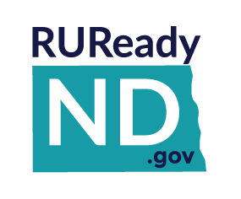
Educators
INTEREST PROFILER

Interest Profiler

The Interest Profiler is an assessment tool which
- helps individuals identify their work-related interests
- gain self-knowledge about their vocational personality type, and
- develop career awareness of matching occupations.
For teachers and counselors, the Interest Profiler is a great classroom activity because it can be done in one class. It is important to remind users that the Interest Profiler is not a test. There are no right or wrong answers, only answers that accurately reflect their own interests. The results should be used for career exploration. The Interest Profiler is appropriate for users 14 years of age or older with eighth grade or higher-level reading skills. Most participants can complete the Interest Profiler and print the results in 5 to 15 minutes.

The Interest Profiler is composed of 60 statements, each describing a work activity. The statements represent activities in a broad range of careers and training levels. Users are asked to choose one of five possible answers for each of the activities: Strongly Dislike, Dislike, Not Sure, Like and Strongly Like.

The Interest Profiler reveals the statements one screen at a time, so users can really focus on each statement. The assessment can be stopped at any time – answered questions are stored in increments of 10, so users can return to the Interest Profiler at the last increment level they completed. For instance, if users answered 35 questions, the system would save questions 1 to 30. If users answered only 8 questions, they would have to start again at question 1 when they returned to the assessment.

At completion of the assessment, the user’s occupational interest areas are presented. These interest areas include: Realistic, Investigative, Artistic, Social, Enterprising, Conventional. Results are then matched with a list of possible careers. Results can also be imported into the Career Finder and combined with other factors in the user's search for occupations, to build a more specific list of results. Users are also encouraged to think about their results and write down their thoughts in their Portfolio Journal.

Student Access: Sign in to RUReady.ND.gov > Career Planning > Learn About Yourself > Interest Profiler

