Name: Teacher: Period:

RUReady.ND.gov Interest Profiler and Career Exploration
- Sign in to your RUReady.ND.gov account:
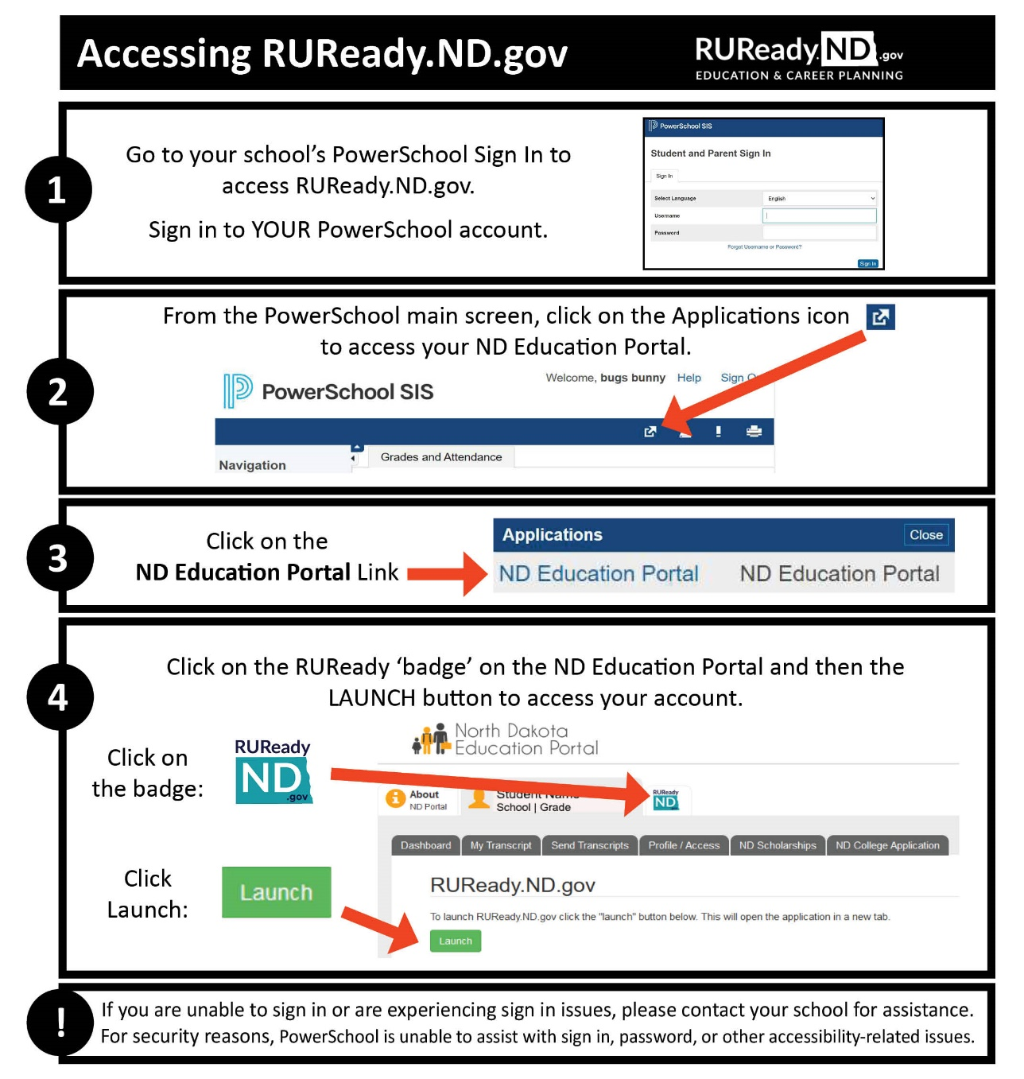
- Click on the Career Planning tab.
- Click on Learn About Yourself
- Click on Interest Profiler
- Click Get Started. Answer the questions using Strongly Dislike, Dislike, Unsure, Like, and Strongly Like.
- Read through your results.
- Complete the Reflecting on your Interest Profiler results at the bottom of the page then click Save. What are your top two interest areas? Circle your top two:
Realistic | Investigative | Artistic | Social | Enterprising | Conventional
- Click Matching Careers (located on the top or bottom of the page on the right side).
- Spend some time researching matching careers by choosing one of the following:
  - The Best Match tab click a career to see its profile.
  - The Education Level tab to view careers at certain education levels, i.e., Professional or graduate degree, Bachelor's degree, one to two years post-secondary training, High school completed (GED), High school not completed (but preferred).
Tip! Click on the stars in the Your Match column to see how closely you match the interest profile of the career.
- Locate Refine Your Search on the left side of the page. Click on Use these interests in the Career Finder to combine your interests with earnings, education and other characteristics.
- At the bottom click See Your Matching Careers (to add interest results to search).
- To add more characteristics to your search, choose the characteristic you’d like to add by clicking on it and making your choices.
  - For example, on the left side, click on Education Level. Choose the level of education you would like to complete after high school (not the level you have now). Click See Your Matching Careers.
- If you have no careers that match all the characteristics you selected, change your selections or click on View careers that match all but 1 of the characteristics you selected.
- You can sort your list by State Average Annual Earnings (click twice so the highest paid positions are at the top of your list).
- From your lists, what are four careers that interest you now?
1. _____________________________________ 2. ________________________________________
3. _____________________________________ 4. ________________________________________

Career Exploration
Directions: Choose one career from your list on page 1 and answer the following questions.
What career are you researching?
- Click on that career in the list. Watch the career video (if available) then read about What They Do.
  - What career cluster/career pathway does this career fall under?
Career Cluster: _______________________ Career Pathway: _____________________________
  - List three of the typical tasks/responsibilities this career requires you to do.
1.
2.
3.
  - List three of the working conditions and physical demands.
1.
2.
3.
  - What are the working hours? Are there any travel requirements?
Working Hours: __________________ Travel Requirements: _____________________________
  - Look at the Specialty or Similar Careers list. List two or more other careers that are similar or related to the career you selected.
1. ________________________________ 2. __________________________________
- Click on the Is This for You tab on the right. Does this career match your Interest Areas, your Work Values, your Aptitudes? Circle the Interest Areas that are listed for this career:
Realistic | Investigative | Artistic | Social | Enterprising | Conventional
  - Which TWO Interest Areas are your top interest areas? (Circled in #8 on page one)
1. ________________________________ 2. __________________________________
  - Are your interest areas the same or different? __________________________________________
  - List 2 Work Values for the career you are researching:
1. ________________________________ 2. __________________________________
  - List 3 Aptitudes for the career you are researching:
- ________________________ 2. ________________________ 3. _______________________

- Click on Skills Needed on the right.
  - List 4 Basic Skills that are important for this career.
1.
2.
3.
4.

List 3 Transferable Skills used in this career that are also used in other careers.
1.
2.
3.

Read about Workplace Skills and list at least 1 workplace skill used in this career:
1.
- Click on the What to Learn tab on the left.
  - Under High School, what Cluster and Pathway should you look at to learn more about the courses that are recommended in high school?
Cluster: ________________________________ Pathway: ________________________________
  - Under Beyond High School are there any programs listed that you should consider if you’re interested in this career?
Program(s) listed: _________________________________________________________________
  - Scroll down to Education Level. Is an education level beyond high school required? ☐ YES ☐ NO
If yes, what kind of degree is required and how many years will it take to complete? (Scroll down to the bottom of the page to see if there are any Extra Requirements.)
Degree _____________________________________ How many years to complete? __________
Add any Additional Information or Extra Requirements you think are important: ________________________________________________________________________________
________________________________________________________________________________
- Click on the Money & Outlook tab.
- How much money can you earn in this career in North Dakota? Nationally?
North Dakota Average Annual Wage:
(If North Dakota is not listed, answer with N/A.)
National Average Annual Wage:
What is the National Employment and Outlook for this career?
Outlook: _____________ Job Openings_________________ Employment: ________________
Growth: ________________________ Industries: ____________________________________
- Are there Military Options for this career? ☐YES ☐ NO

- Earnings:
- Services offering this occupation:
- Read more about this career under the Connections tab. You can find out about associations, internet sites, related career information, military career opportunities and access to job banks by state. You can also learn more by reading information on the Interview tab, if provided.
- Practice on Real-Life Activities and see if you have what it takes!
- Is this a career that you would consider? ☐YES ☐ NO
Why or why not?

- What questions do you still have?

Additional activities:
      - Compare to Another Career
      - Start a Career Plan

