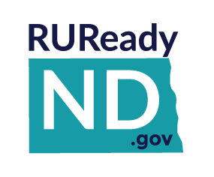
THE CAREER KEY
Educators

- The Career Key is found in RUReady.ND.gov in the Career Planning tab under Learn About Yourself.
- Students must be signed in to their RUReady.ND.gov account to access the survey.
The Career Key is an assessment tool catering to middle school students. It helps individuals identify their work-related interests, gain self-knowledge about their vocational personality type, and develop career awareness of matching occupations. Like the Interest Profiler, The Career Key assesses Holland personality types which include Conventional, Social, Enterprising, Artistic, Realistic, and Investigative
The Career Key takes 10 to 15 minutes to complete. Results from the Career Key can be compared later to results from the Interest Profiler. Users make selections in five categories –careers of interest, your interests, your abilities, how you see yourself and your values. The Career Key then returns a Results page, ranking the user’s interest areas based on the Holland personality types, and emphasizing the user’s top two interest areas. On this page, users can jot down their thoughts about their results in the “Reflections” field.
The Career Key then offers a Careers page, listing careers that match the user’s interests. By clicking any of the career titles, users can obtain detailed information about the career. Results from The Career Key assessment are automatically stored in Your Portfolio in the Career Planning section under All About You.
If users start the Career Key but do not complete it, they can continue where they left off when they return to the assessment later. They can also choose to start over and discard the partially completed assessment.

