Name: Teacher: Period:

Career Exploration with RUReady.ND.gov
CAREER ASSESSMENT – CAREER KEY
What do I want to do? What are my goals?

- Sign in to your RUReady.ND.gov account:
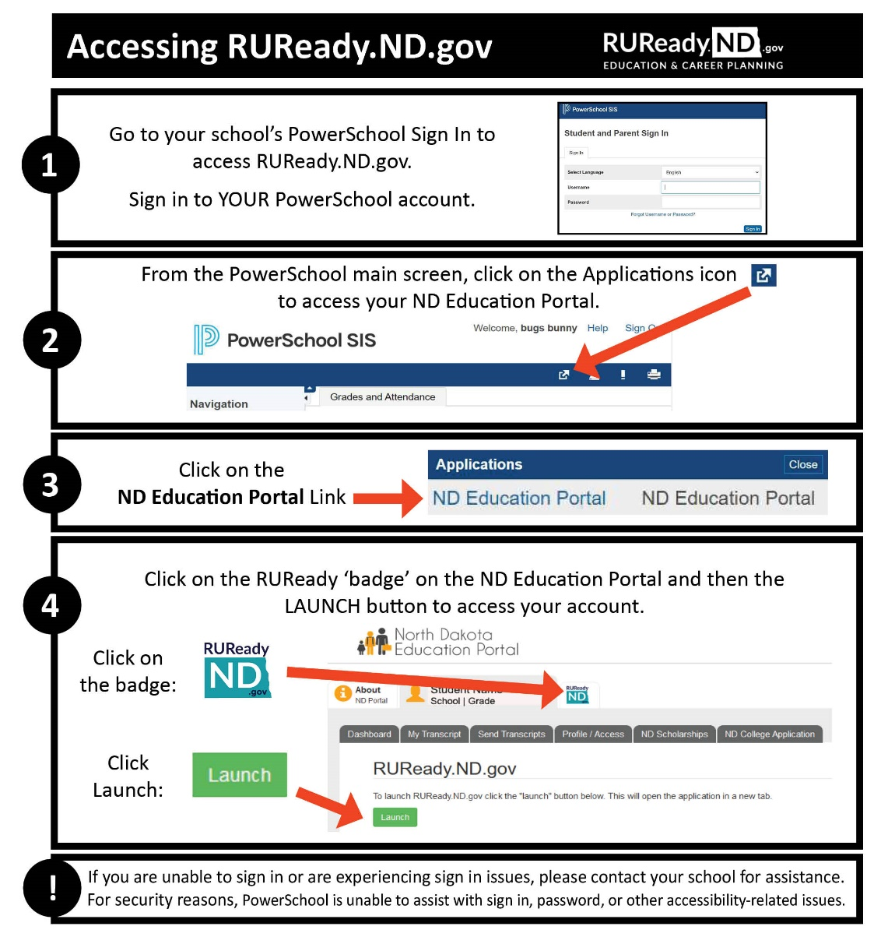
- Click the CAREER PLANNING tab.
- Click on Learn About Yourself.
- Click on The Career Key.
- Click Get Started.
- Complete the checklists.
- Read through your results. What are your top two Interest areas? (Circle your top two below)
Realistic | Investigative | Artistic | Social | Enterprising | Conventional
- At the bottom of the page under Your reflections on your results from the Career Key: Answer the questions and Save.
- Click View Careers on the bottom of the results.
- Spend some time researching matching careers by choosing one of the following search tools:
- Under the Careers heading click a career to see its profile.
- Choose the Education Level heading to view careers at certain education levels.
- You can also sort your list by State Average Annual Earnings (click twice so the highest paid positions are at the top of your list).

- From your list, what are four careers that interest you now?
1. _____________________________________ 2. ________________________________________
3. _____________________________________ 4. ________________________________________

Career Exploration
Directions: Choose one career from your list above and answer the following questions.
What career are you researching?
- Click on that career in the list. Watch the career video (if available) then read about What They Do.
  - What career cluster/career pathway is this career a part of?
Cluster: ________________________________ Pathway: ________________________________
  - List three of the typical tasks/responsibilities this career requires you to do.
1.
2.
3.
  - List three of the Working Conditions and Physical Demands.
1.
2.
3.
  - What are the working hours? Are there any travel requirements?
Working Hours: __________________ Travel Requirements: _____________________________
  - Look at the Specialty or Similar Careers list. List two or more other careers that are similar or related to the career you selected.
1.
2.
- Click on the Is This For You tab on the right. Review the Interests, Work Values, and Aptitudes for this career.
- Circle the Interest areas that are listed for this career:
Realistic | Investigative | Artistic | Social | Enterprising | Conventional
  - Which two Interest areas are YOUR top interest areas? (Circled in #7 at the bottom of page one)
1. ________________________________ 2. __________________________________
  - Are your Interest areas the same or different? ☐ Same ☐ Different
  - List two Work Values for the career you are researching:
1. ________________________________ 2. __________________________________
  - List two Aptitudes for the career you are researching:
1. ________________________________ 2. __________________________________
- Click on the What To Learn tab.
  - Under High School, what Cluster and Pathway should you look at to learn more about the courses that are recommended in high school?

Cluster: ________________________________ Pathway: _________________________________________
  - Under Beyond High School are there any programs listed that you should consider if you’re interested in this career?

Program(s) listed: ________________________________________________________________________
  - Scroll down to Education Level. Is an education level beyond high school required? ☐ YES ☐ NO
If yes, what kind of degree is required and how many years will it take to complete? (Scroll down to the bottom of the page to see if there are any Extra Requirements.)

Degree _____________________________________________ How many years to complete? __________
Extra Requirements______________________________________________________________________
  - Read Insider Info for more information about this career (if available). List 2 things you learned:
1.
2.

- Click on the Money & Outlook tab.
- How much money can you earn in this career in North Dakota? Nationally?
1. North Dakota Average Annual Wage:
(If North Dakota is not listed, answer with N/A.)
2. National Average Annual Wage:
3. What is the National Employment and Outlook for this career?
Outlook: _____________ Job Openings:_____________________ Employment: _____________________
Growth: __________________________ Industries: ___________________________________________
- Is this a career that you would consider? ☐ YES ☐ NO
Why or why not? Be specific. ________________________________________________________________________
________________________________________________________________________________________________
- Click on the Military Options tab. Does the military offer this career? ☐ YES ☐ NO
  - If yes, list the branches of military service that offer this career: _________________________________________________________________________________________
- Click on the Connections tab. Name 2 or 3 other Connections related to this career, i.e., associations, Internet sites:
________________________________________________________________________________________________
- You can search for jobs in this career in North Dakota and nationally on the Connections page. What job banks are offered when you choose North Dakota?
North Dakota: _____________________________________________________________________________
National: _________________________________________________________________________________
- Click on the Interview tab. If provided, read through the Interview for this career. After reading the Interview, do you think this career sounds like what you thought it would be? ☐ YES ☐ NO
- Click on the Real-Life Activities tab. Complete the Real-Life Activities for this career. What are your results?
Real-Life Math Activity: _____________________________________________________________________________
Real-Life Decision-Making Activity: ____________________________________________________________________
Real-Life Communication Activity: _____________________________________________________________________
Other Activities:  - Compare to Another Career  - Complete a Career Plan | What questions do you still have?

