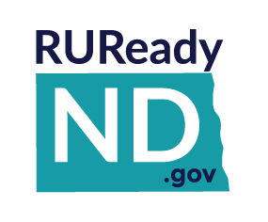
CAREER CLUSTER SURVEY
Educators

- The Career Cluster Survey is found in RUReady.ND.gov in the Career Planning tab under Learn About Yourself.
- Students must be signed in to their RUReady.ND.gov account to access the survey.
The Career Cluster Survey is a short quiz that can help users narrow down a Career Cluster for further research. Career clusters are groups of careers that share similar skills and interests. The Career Cluster Survey does not replace validated tests like the Interest Profiler, however; it makes an excellent starting point for students who need help finding a general direction for their career exploration. Most participants can complete the Career Cluster Survey in 15 to 25 minutes.
Students interested in specific careers can find related options that might interest them by using the clusters. For example, a student who is interested in becoming a physician, but is wary of the length of required education, can find similar careers by looking in the Health Science cluster. The survey asks users questions about themselves, and then gives them a list of clusters matching their criteria.
During the quiz, students complete three checklists -- an activities checklist, choosing the activities they are interested in, a personal qualities checklist, selecting the words that best describe themselves, and a school subjects checklist, indicating the school subjects that they enjoy most.
The Career Cluster Survey then displays a list of career clusters matching the user’s selections. By clicking on a cluster heading, users can learn more about that group of careers. They can also view the careers, programs or high school course plan for a cluster. Users can combine their top career clusters with earnings, educational levels or other characteristics to help narrow down their search the Career Finder.
A bar graph ranks the user’s clusters -- from the closest match to the furthest match. The user’s survey selections are also listed so users can review their earlier choices. Users can add a cluster to their portfolio. They’re also encouraged to think about their results and write down their thoughts in their Portfolio Journal.

