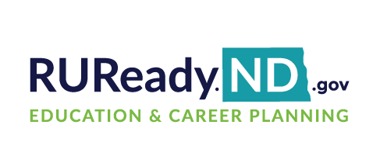
Name: Teacher: Period:
Career Cluster Survey
- Sign in to your RUReady.ND.gov account:
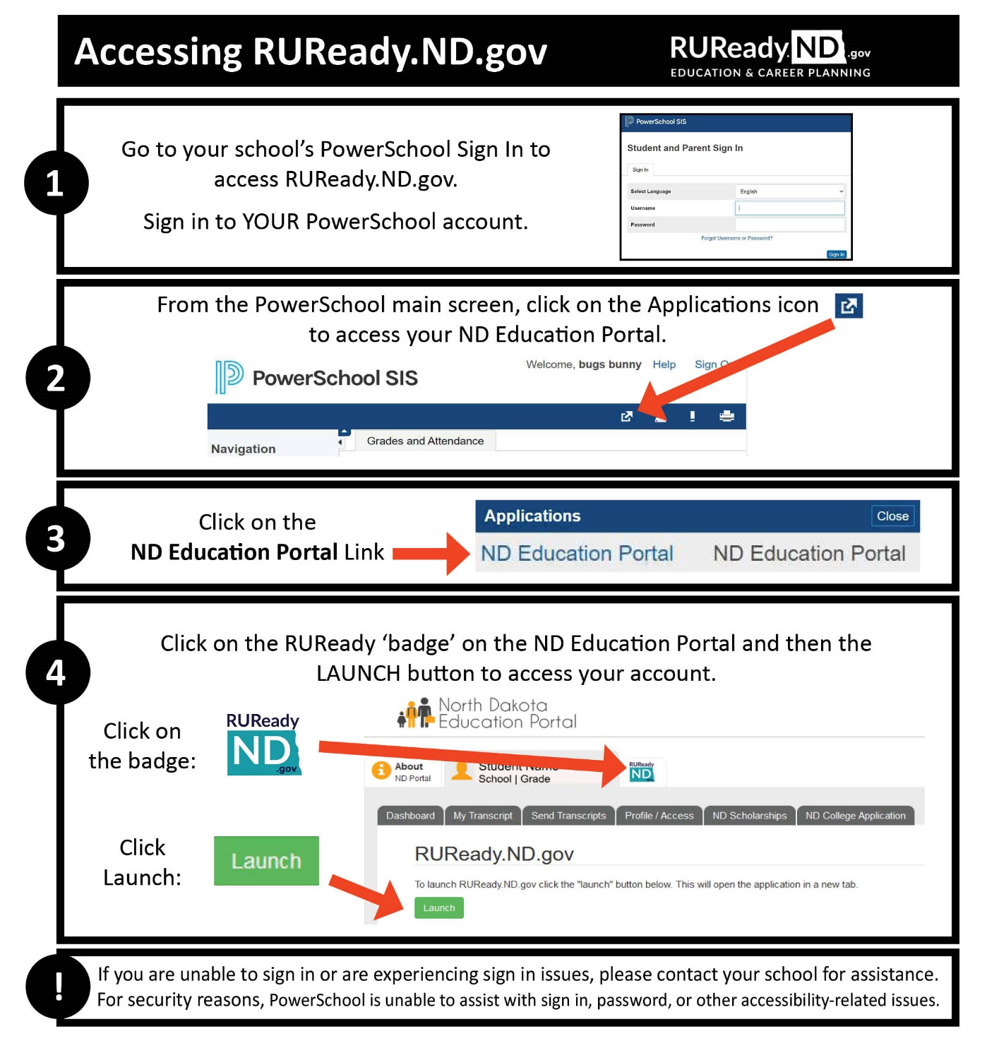
- Click on the Career Planning tab.
- Click on Learn About Yourself
- Click on Career Cluster Survey
- Click on Start
- Check the boxes of things you would like to do in the future, and the ones you are interested in and can do now. Complete each page and click continue through all 7 pages to the Results page.

- On the Results page, your selections are listed for you to go over. If you would like to go back and take the survey again to make some changes you may do so.
From your results, My Top Clusters, circle your top two or three clusters:
Agriculture, Food & Natural Resources | Education & Training | Hospitality & Tourism | Manufacturing
Architecture & Construction | Finance | Human Services | Marketing, Sales & Service
Arts, Audio/Video Technology & Communications | Government & Public Administration | Information Technology | Science, Technology, Engineering & Mathematics
Business, Management & Administration | Health Science | Law, Public Safety, Corrections & Security | Transportation, Distribution & Logistics
- Review Your Survey Selections (a breakdown of each section and the options you chose): *If your selections don’t match who you are, you can retake the survey.
  - Activities You Like: Do your selections match what you like? Yes or No (circle your answer)
  - Personal Qualities: Do the personal qualities reflect who you are? Yes or No (circle your answer)
  - School Subjects: Did you choose the subjects that are interesting to you? Yes or No (circle your answer)
- Complete the Does This Sound Like You? My Reflection results box at the bottom of the page. Save.
- Click on the bar graph of one of Your Top Career Clusters. This will take you to an Introduction of the cluster and provide information on pathways in this cluster, careers, employment outlook, etc. To save this cluster click Save to Portfolio.
- In the menu on the right side of the page, click on Careers. Click Sort by Education Level.
- Click on the career of interest to learn more. Watch the video, if available, and click on each menu item on the right for specific information. If you would like to save a career, click Save to Portfolio.
- List 3 careers that interest you now and list below. Also, include the required education level for each:
Career #1 _______________________________________________ # years college/training _______
Career #2 _______________________________________________ # years college/training _______
Career #3 _______________________________________________ # years college/training _______
- When finished, click on the YOUR PORTFOLIO tab in the main menu (top right corner).
- Click on Your Journal
- Click on Add a new journal entry.
- For your Journal Entry, type in this sentence, entering the careers you chose in question 12 above.
Today I am most interested in _________career________ which requires ______ years of college/training); _________career________ which requires ______ years of college/training; and, _________career________ which requires ______ years of college/training.
- Click Save

MORE ACTIVITIES

Step 1: Click on the Career Planning tab. Click on Explore Careers. Under Browse Career Clusters, click on your top cluster from the Career Cluster Survey you took to see a list of careers to explore.
Write down two careers from your list that you find the most interesting.
1. ____________________________________ 2. ____________________________________
*If a video is available, watch it to learn about the career and find out what they do. Read more about these careers.
Step 2: Click on the Career Planning tab. Click on Explore Careers. Click on Career Finder. In the menu on the right side of the page, click on School Subjects. Select one school subject you are interested in and click on See Your Matching Careers. Select one career that interests you. Write it here and save it to Your Portfolio.
___________________________________________________________________________________
Is the career you chose for this step in your top career cluster? ☐ YES ☐ NO
If not, which career cluster is the career a part of?
___________________________________________________________________________________
Click on the Career Planning tab. Find Check out this library of advice from career experts. Select Career Planning. Select read Plot Your Career Path. Write 1-2 sentences about what you learned:
___________________________________________________________________________________
___________________________________________________________________________________
___________________________________________________________________________________

This worksheet is for you to use and share with your guardian(s).
- Start the conversation about your future. How are you saving for college? What are your goals? What do you need to do to achieve your goals?
- Share the RUReady.ND.gov website with your guardians to help you prepare for the future. You can access the RUReady.ND.gov any time, at school or at home, and use it for career and college planning.

