Advance CTE Empowering Student Success Through Career Advising and Career and Technical Education
# | Resource | Item
1 | Recording | Recording Day 1:  https://cccs-edu.zoom.us/rec/share/erDBoCSRZhjRnVapo8Wh4Fxx2CJxtne1c3Ej4DXfUXbGwc_Yjsih60jtuyKfAEdV.FOfDKCQzlnXt9LnU  Passcode: +naDf4r2
1 | Recording | Recording Day 2:  https://cccs-edu.zoom.us/rec/share/1DiArqGjXzMdXBii7bvZlgAYJI-Fa-M1U3ecNtiy1Qj3BNvVIDo5cQ5RtTI5eINg._X4hnfd-AaM5oxdI  Passcode: P8GE+Ftb
3 | Jamboard 1 | Jamboard: Career Advisement Strategic Actions  https://jamboard.google.com/d/1kP6WtgfZjrusowS_2p8VtSZp6AeB9hR9poHgxtcv69A/viewer?f=0
3 | Jamboard 2 | Jamboard: Unintended or implicit bias can affect students decisions related to CTE  https://jamboard.google.com/d/1j01WQLVnsBGOtUPkW07UVR5e0ssBA6riTe20g3FgKd8/viewer?f=0
3 | Jamboard 3 | Jamboard: CTE Components  https://jamboard.google.com/d/1WqqJiELJmc87SD80_m6rbiUb1dcn0L3QvBUcV5ep7NI/edit?usp=sharing
3 | Jamboard 4 | Jamboard: Doing/Using LMI Resources  https://jamboard.google.com/d/1zac1d2yXNVVbD0ej-O1qlWK3bA3gDXGHPcuTJRqU8pE/viewer
3 | Resource | North Dakota Career Planning Continuum  https://www.cte.nd.gov/sites/www/files/documents/CareerDev/CCSSO_ContinuumWithResources.pdf
3 | Resource | Participant Workbook
3 | Resource | Supporting School Counselors & Career Advising Stakeholders  https://careertech.org/resource-library-empowering-students-through-career-technical-education-and-career-advising%C2%A0
4 | Resource | Draft Community Agreement
4 | Resource | Handout Hub
4 | Resource | Menti Survey Results
4 | Resource | Without Limits: A Shared Vision for the Future of Career Technical Education

Jamboard 1 – Career Advisement Strategic Actions

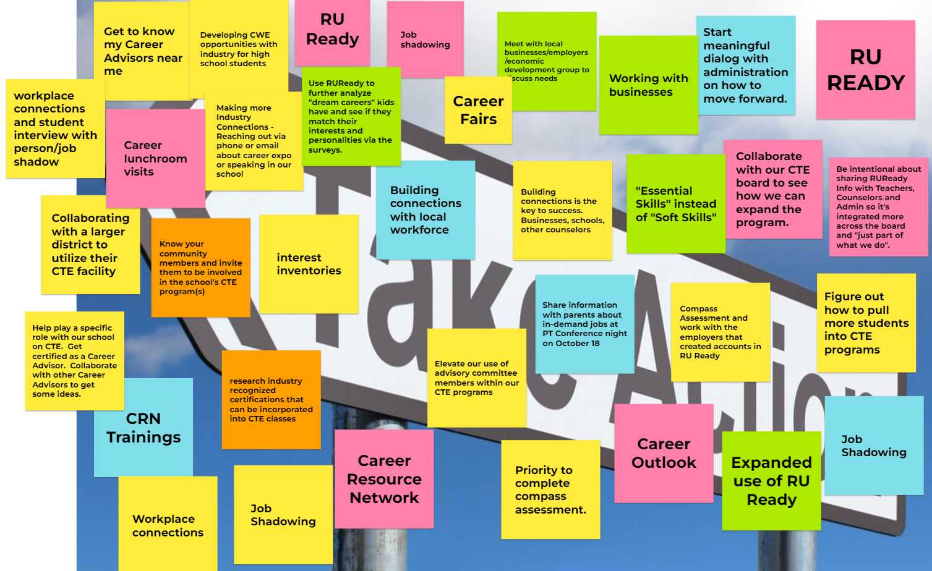
Jamboard 2- Unintended or Implicit Bias Effects 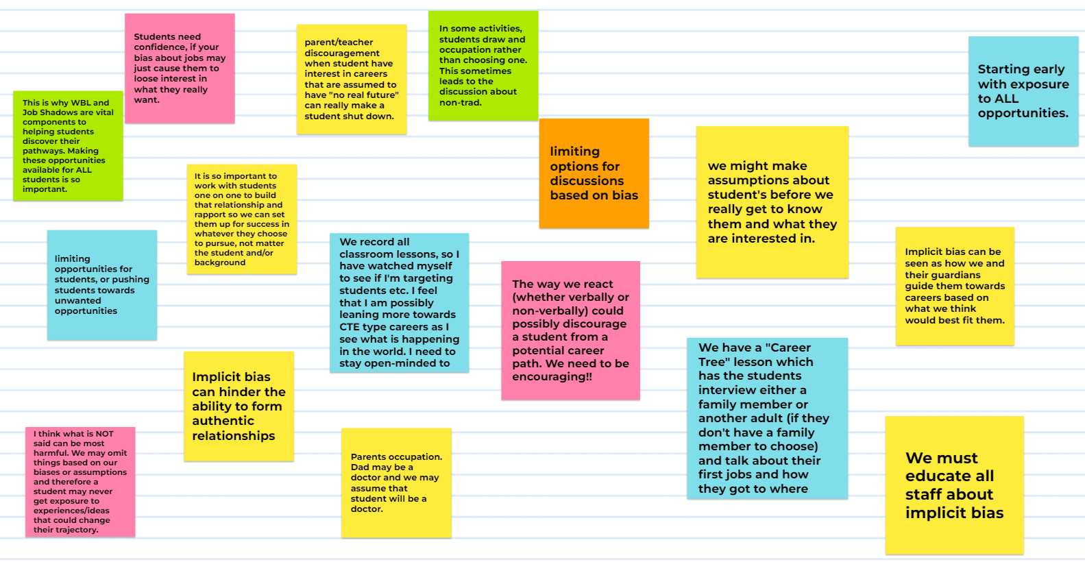

Jamboard 3 - CTE Components (1)
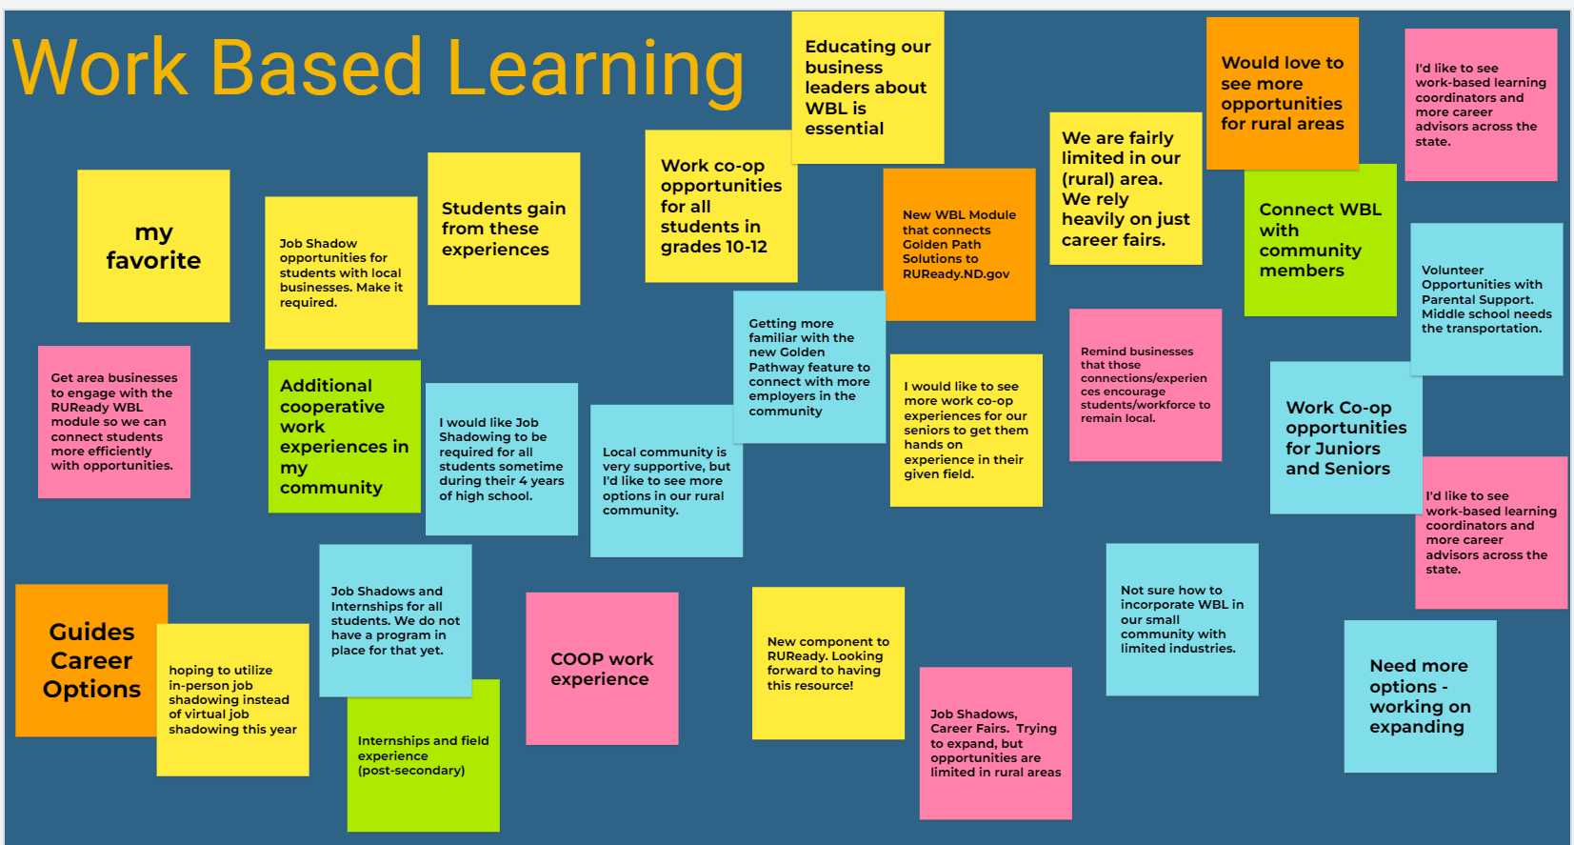

Jamboard 3 - CTE Components (2)
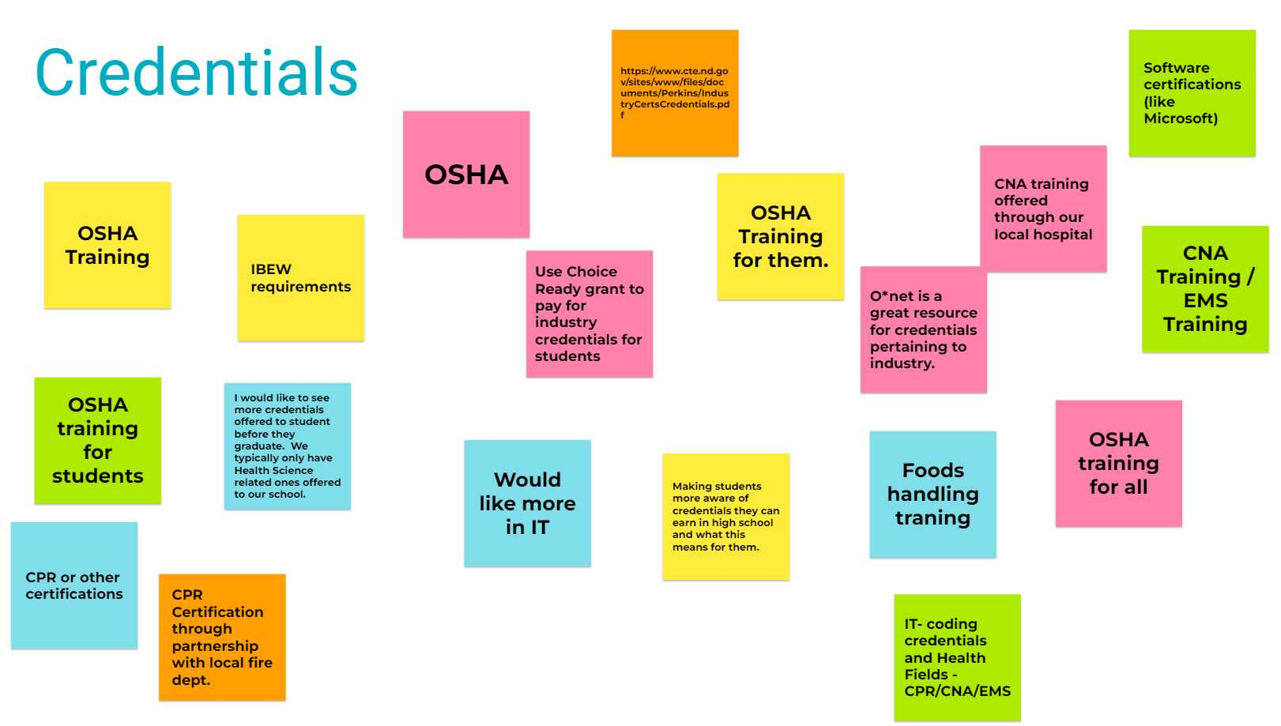

Jamboard 3 - CTE Components (3)
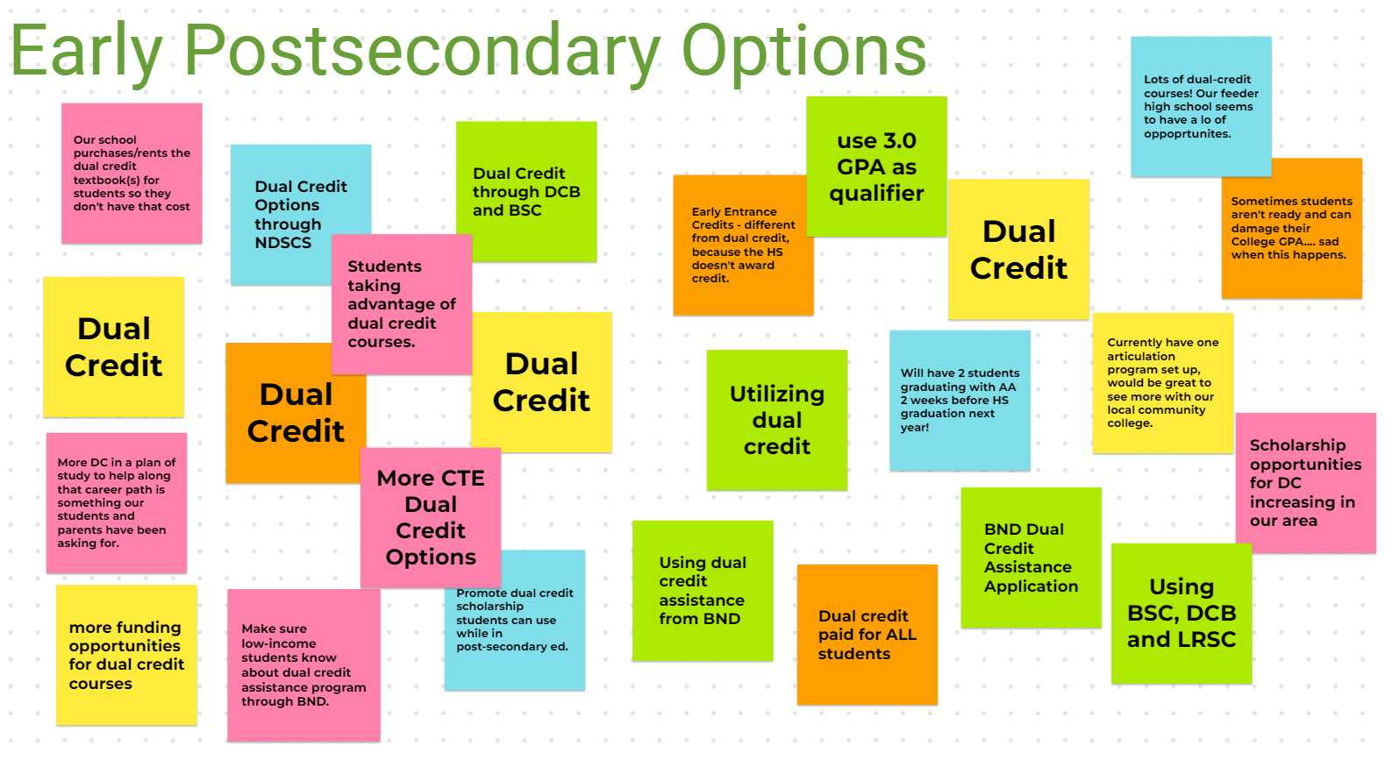

Jamboard 3 - CTE Components (4)
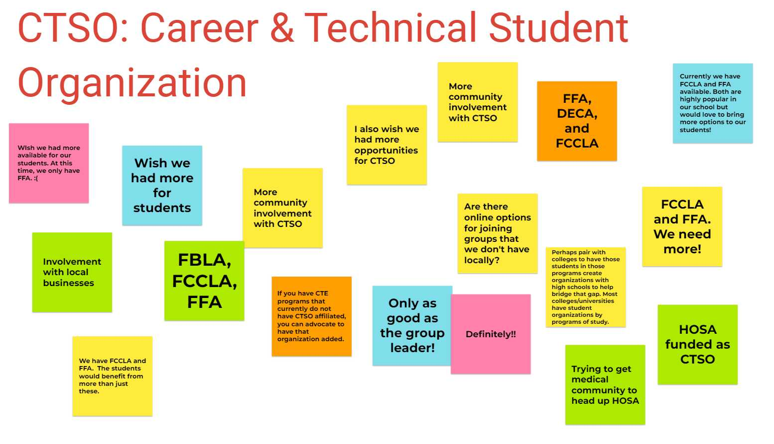
Jamboard 4 – Doing/Using LMI Resources